**Lab task:**

1. Factorial is the product of all positive integers less than or equal to the number. Write a C program that calculates the factorial of a number using a for loop.

**Requirements:**

* Use a for loop to calculate the factorial.
* Ensure the input is a positive integer.

**2.** Write a C program that takes an integer input from the user and prints all even numbers from 1 to that integer using a while loop.

**Requirements:**

* Use a while loop.
* Validate that the input is greater than or equal to 1.
* Print all even numbers between 1 and the input number.

**3.** Write a C program that keeps asking the user to input a positive number. The loop should stop once the user inputs a valid number using a do-while loop.

**Requirements:**

* Use a do-while loop.
* Validate the input so it only stops for a positive number.
* Display the final accepted input.

Example:  
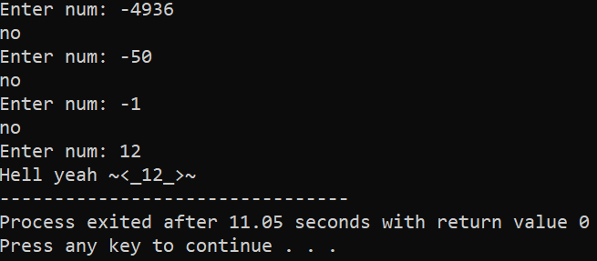

**4.** Which loop would be better for User Input? Justify your answer by creating a program that takes a value and adds it to a variable and prints it repeatedly until the user enters a zero value.

**5.** Write a program to check whether a given number is prime or not.

**6.** Using the above program integrate the number if it is a prime and print the Fibonacci series till that

number.

Example:

**7.** Write a program to check whether a number is an Armstrong number or not. An Armstrong number is a number that is equal to the sum of cubes of its digits.